QUERIES

1. List the name of the managers with the maximum employees

--->

SELECT m.ename, count(*)

FROM employee e,employee m

WHERE e.mgr_no = m.empno

GROUP BY m.ename

HAVING count(*) =(SELECT MAX(mycount)

from (SELECT COUNT(*) mycount

FROM employee

GROUP BY mgr_no) a);

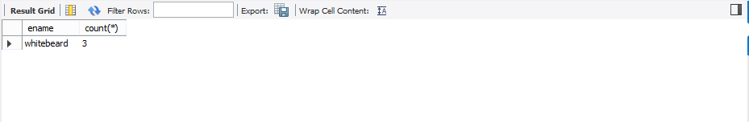

2.

Display those managers name whose salary is more than average salary of his employee.

--->

select m.ename

from employee m

WHERE sal >= (SELECT avg(e.sal)

FROM employee e

where m.empno = e.mgr_no

group by e.mgr_no);

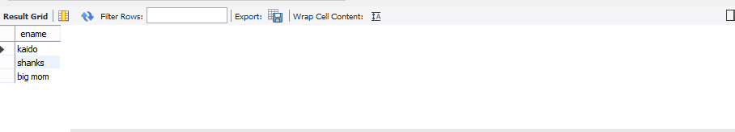

3.

Find the name of the second top level managers of each department.

--->

select ename from employee where empno in(select distinct mgr_no from employee);

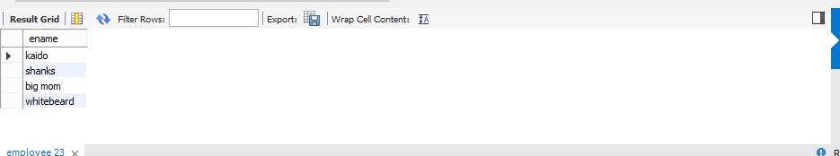

4.

Find the employee details who got second maximum incentive in January 2019.

--->

select *

from employee e,incentives i

where e.empno=i.empno and 1 =

( select count(*)

from incentives j

where i.incentive_amount < j.incentive_amount) ;

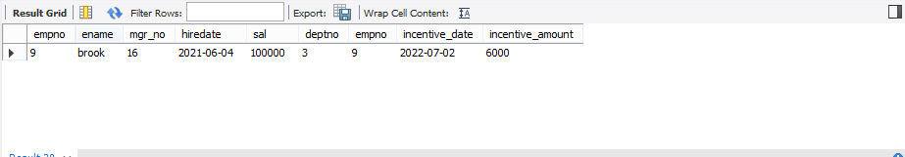

5.

Display those employees who are working in the same department where his manager is working.

--->

select e.empno, e.ename, e.mgr_no, e1.ename as mgr_name, e.deptno, d.dloc

from employee e, employee e1, dept d

where e1.empno = e.mgr_no

and e.deptno = d.deptno

and d.dloc =

(select d1.dloc

from employee e2, dept d1

where e2.empno = e.mgr_no

and e2.deptno = d1.deptno);

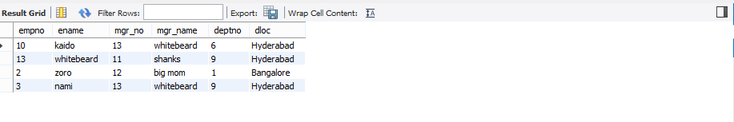

SPOT QUERIES